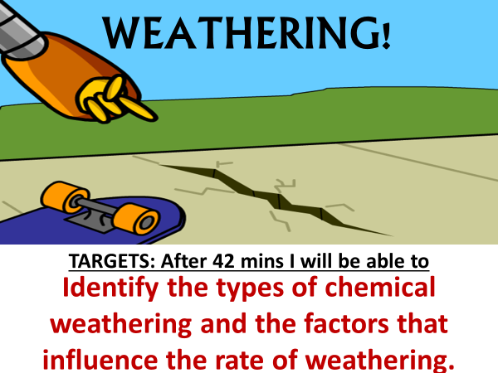
I. Introduction Activity:
PREDICT | OBSERVATIONS | EXPLAIN
What do you think will happen once you drop the Alka Seltzer Tablet into the cup of water? | Draw the setup, what you see during the activity & label what is happening on your drawing. | Was your prediction correct? Create an explanation for the cause and affects you just observed.
GOING FURTHER:
Create another experiment using the same materials to speed up what you just observed:

DEFINE WEATHERING:

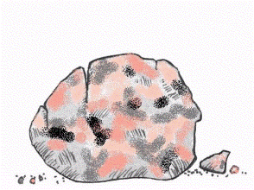
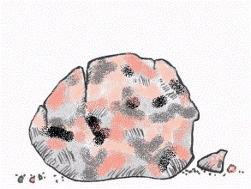
II. This happens to rocks EVERYDAY!!!
Q. What are rocks EXPOSED to that may cause WEATHERING?

A. There are THREE MAIN “SPHERES”

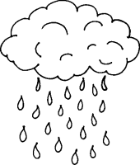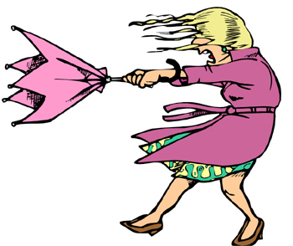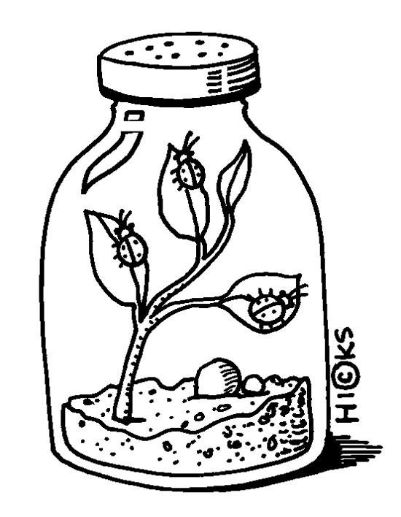

1. _______________ 2. _______________ 3. _______________

III. What are the 2 MAIN TYPES of WEATHERING:

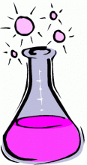

1. 2.

IV. 4 TYPES OF CHEMICAL WEATHERING:
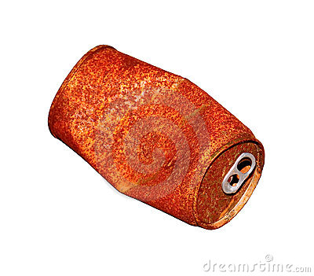
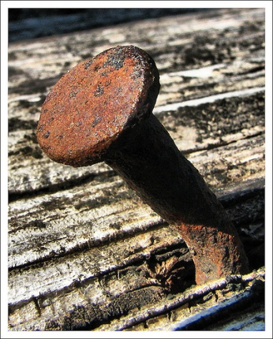
1. _____________________________________

________ + ________ =

______________!

Changes the:

_________________ ___________________!

***________________________________________***

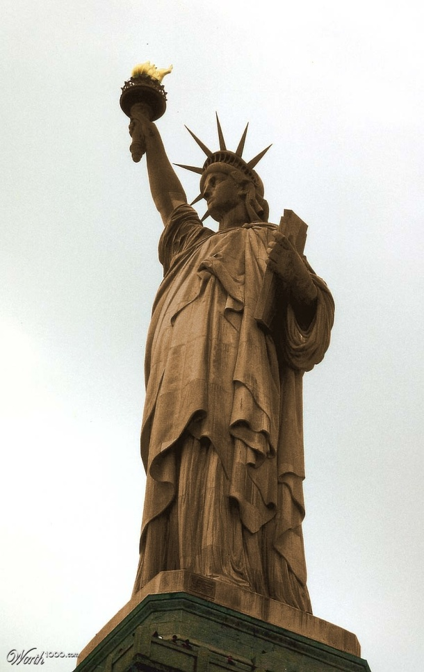

What is this famous USA statue?

BEFORE: ______________

AFTER: _______________

BRAINSTORM:
What caused it to change over time?

What can ACID do?!?!



3. _____________________________________
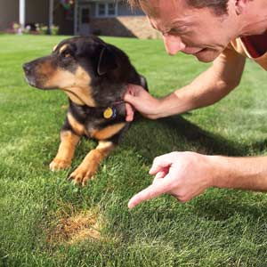
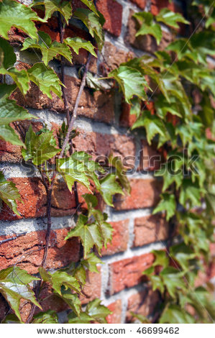

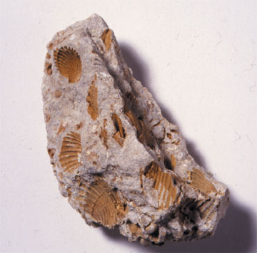
4. _____________________________________

Water w/ _______________ ions break down

__________________________
a SEDIMENTARY ROCK,

Has ________________ in it
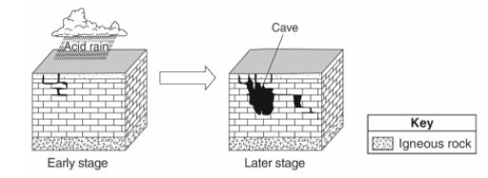
(bubbles w/ acid!)

This MINERAL is also in the METAMORPHIC Rock

________________.
This is why the Taj Mahal has become discolored over time.
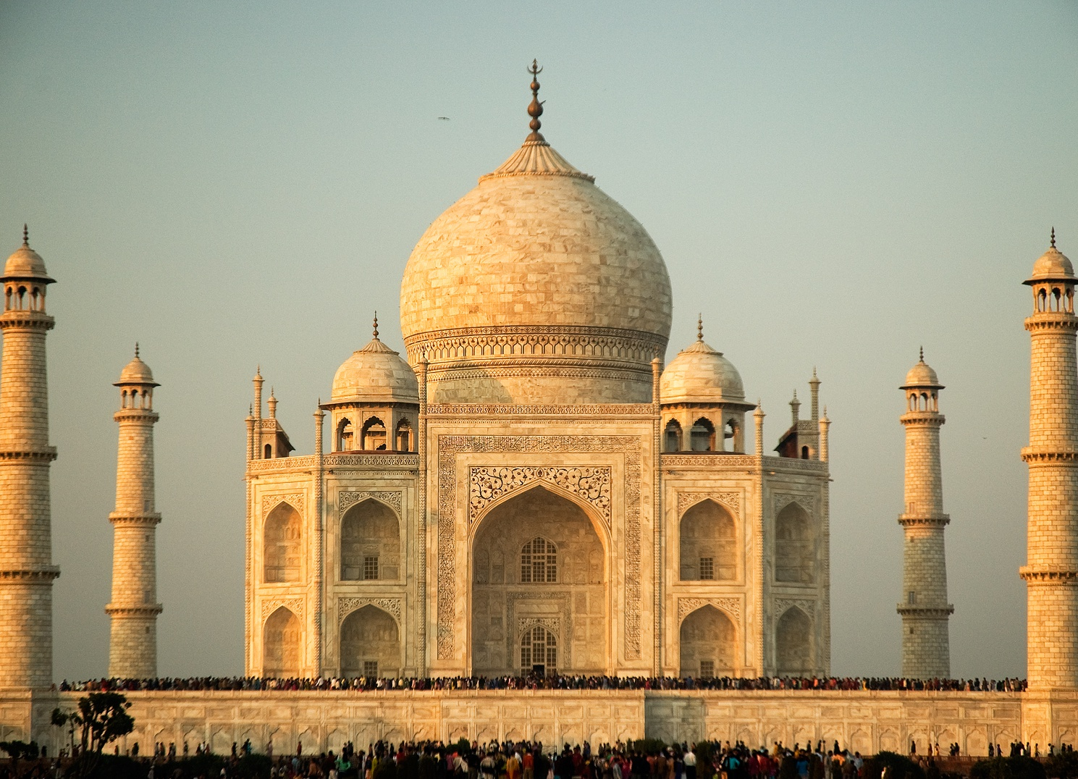

CARBONATION creates

_______________________________

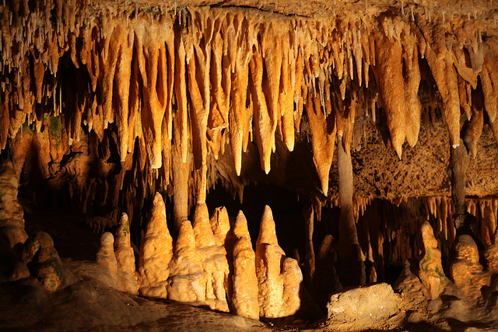
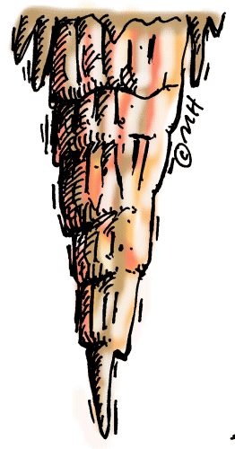
FEATURES:
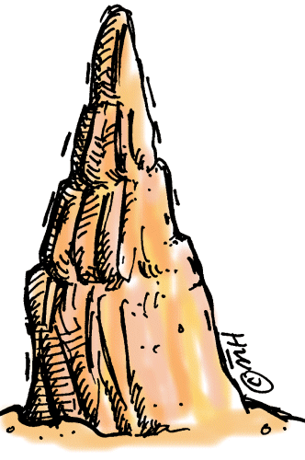
__________________________

_________________________

This creates a ___________ _______________!

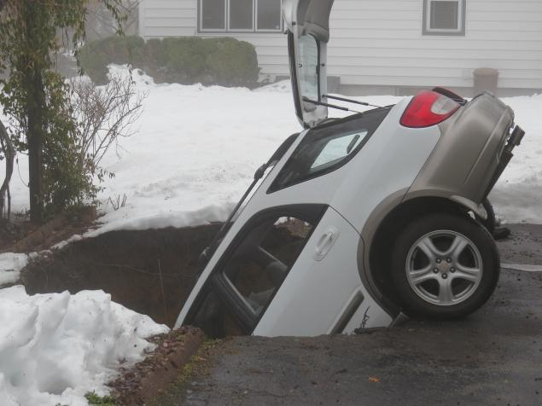
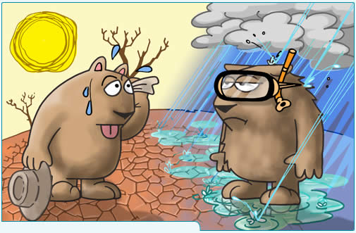
THE RATE OF WEATHERING IS AFFECTED BY:

__________________________________________________________
Think back to the introduction activity.
What could we have done to the TEMPERATURE of the water to increase the rate of weathering?

Chemical Weathering increases in ________ temperatures
( )

Draw the relationship
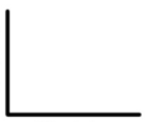
RATE OF
WEATHERING
TEMPERATURE

Now think back to hydration and carbonation.

Chemical Watering increases in __________ humidity
( )

Draw the relationship :

RATE OF
WEATHERING
HUMIDITY

APPLICATION:
Which BIOME (think back to Living Environment last year) would have the fastest rate of chemical weathering?

